Task 15 Kubernetes

Verify WSL is Ubuntu & version
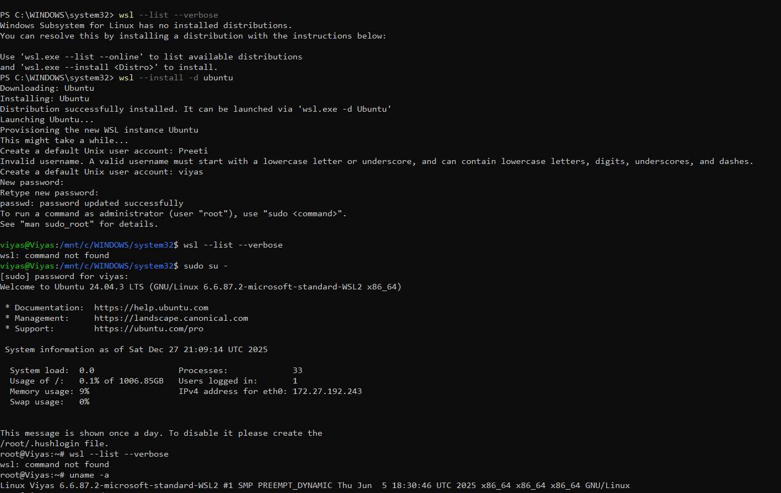

Start Kubernetes cluster
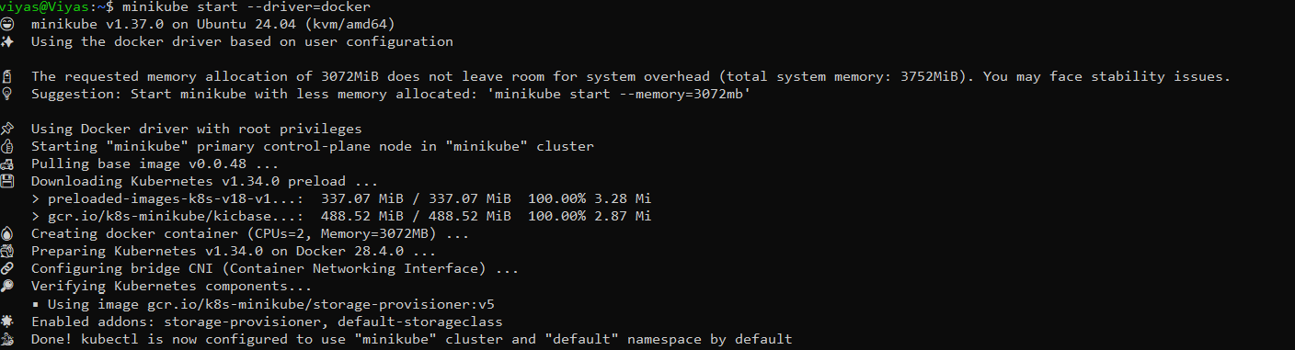

Verify cluster and namespace created
